Paradise Beach, Salud, Panama

Titled Caribbean Beachfront Property

Salud is located on Panama’s Caribbean Coast, 1.5 hours from Panama City and 1 hour West of the Panama Canal. It is close to the cruise ports and the transcontinental train connecting the Pacific and Caribbean. When the new Gatun Locks Bridge, (currently under construction), is finished, it will take 1 hr. from Panama City to this outstanding property.

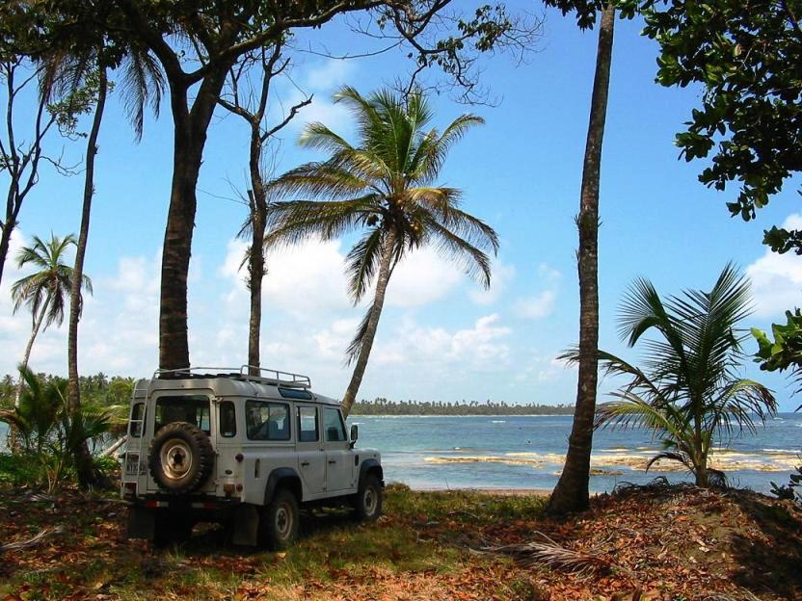

PRICE - $591,000. USD

Total Area: 38,806 Sq. Mts.
Approximate 4 Hectares = 10 Acres
Beach Frontage: 820 lineal Feet = 250 lineal Mts.
North boundary: Caribbean Sea
South boundary: Main Paved Road

Property Characteristics

- Breathtaking Location next to 1000 Hectares destined to be one of the most important tourism projects in Panama!
- Gorgeous and Pristine Sea
- Water, Electricity and Telephone Utilities serve the area.
- Paved Road serves as access to the property
- Close to Panama City and Airport. When the new Colon – Miguel De La Borda Highway is finished, the driving time from Panama City to Salud will be approximately one hour.
- Access by land, air and sea
- Close to Cruise Ports
- Close to Transcontinental Train
- Within Designated Tourism Zone

Zone 5 – Metropolitan
= Applies for ALL Fiscal Exemptions under Law 8

The Panamanian Government has set tourism as one of its main priorities and has allocated significant resources towards this goal. On top of this, numerous fiscal incentives are available to those investing in hotels, marinas and tourism related activities in the Republic of Panama.

Note the limits of the METROPOLITAN TOURISM ZONE, designated by the Panamanian Tourism Bureau as ZONE 5 and extending to include Los Uveros, Salud on the Caribbean.

- Tourist Attractions
Caribbean Sea
Vulcan Reef - One of Panama’s top fishing spots on its Caribbean side
San Blas Archipelago – over 365 islands and cays inhabited by the friendly Kuna
Chagres River – excellent tarpon fishing, kayaking and beautiful scenery
Gatun Lake – Striking scenery, great fishing, dinghy sailing, kayaking, water sports
Fort San Lorenzo – Ruins of a 16th Century Spanish Fortress
Achiote Road Bird Haven – Ranked among top birding sites in the world
San Lorenzo National Park – offering hiking trails and a plethora of flora and fauna
Panama Canal – Gatun Locks - one of the great engineering wonders of the world
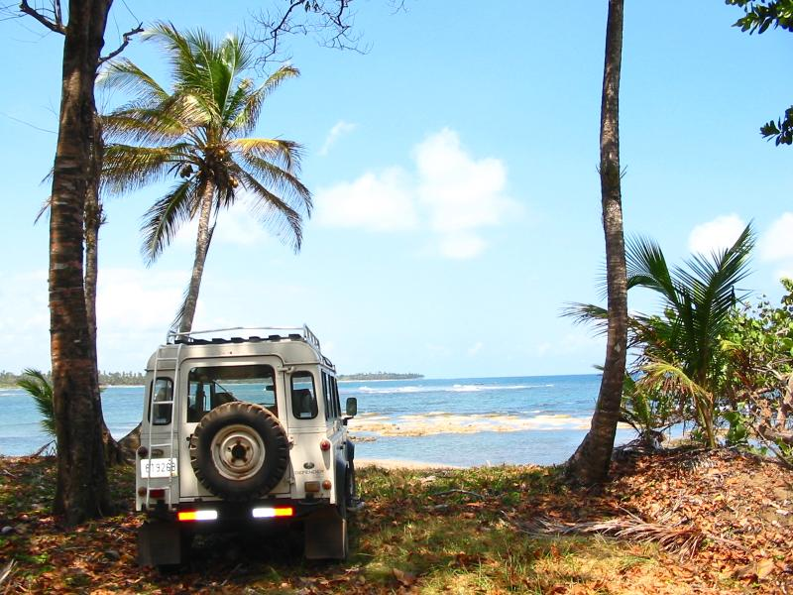
49rs route across the Isthmus – Trans-isthmian train.
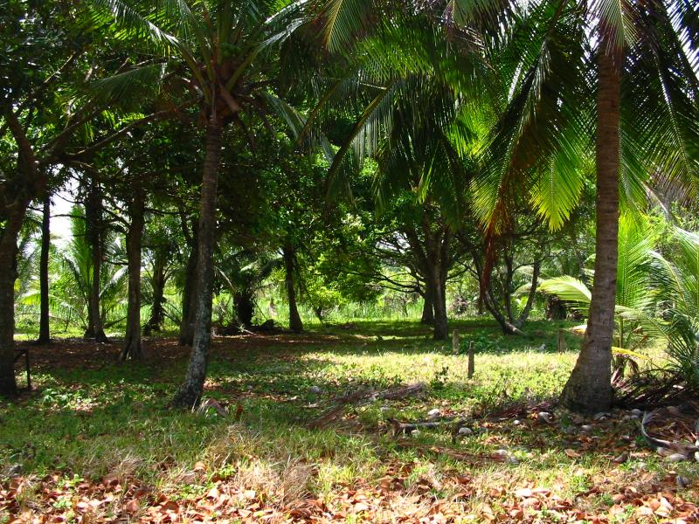

Access

France Field Local Airstrip
Serving private and charter flights in France Field, 15 minutes from Gatun Locks.

Highway
At present the driving time from Tocumen International Airport is one hour thirty minutes. When the new, (currently under construction), Gatun Locks Bridge is finished, the driving time from Panama City will be about 1 hour.

Transcontinental Railway

Serving between Panama City and Colon City over what is known since the California Gold Rush as the 49rs route. Recently put in service by Kansas City Railway, this train ride is world class and offers magnificent scenery. It was rated as the best new tour among Cruise lines in the Caribbean in 2002.

Cruise Terminals in Colon
1 hour from Los Uveros are the cruise terminals. Over 160 cruise ships are currently calling at the cruise ports in Colon. Arrivals keep incrementing. Cruise Lines include Princess, Norwegian, Carnival, Celebrity, SilverSea, Royal Caribbean.

Shopping:
The cruise terminal includes a big supermarket as well as shops offering products ranging from electronics to Cartier watches and Gucci handbags. Additionally, a new shopping center, Millenium Plaza, is under construction and will include a Sheraton Four Points Hotel. 1 hour away is Panama City, boasting plentiful retail shopping opportunities in numerous malls including the newer malls of MultiCentro, Albrook, and Pacific Mall.

Marinas
Over 1,400 pleasure boats cross the canal every year. Additionally, to the East is the San Blas Archipelago, which with its 365 + islands and cays is the ultimate sailing paradise to even the most seasoned skippers.
Existing marinas in the area include
Shelter Bay Marina, Fort Sherman - New Marina
Panama Canal Yacht Club, Cristobal - Traditional Marina

Attractions
The entire region abounds with outdoor recreational opportunities. Starting with the main attraction, the calm waters of the Caribbean, to fresh and saltwater fishing, rivers and lakes for kayaking, scenic pastures apt for horseback riding, hiking trails in the forest, and bird watching. The list goes on.

Caribbean Sea
Vulcan Reef (Panama’s top fishing spot on its Caribbean side).
San Blas Archipelago – over 365 islands and cays inhabited by the friendly Kuna
Chagres River – excellent tarpon fishing, kayaking and beautiful scenery
Gatun Lake – Striking scenery, great fishing, dinghy sailing, kayaking, water sports
Fort San Lorenzo – Ruins of a 16th Century Spanish Fortress
Achiote Road Bird Haven – Ranked among top birding sites in the world
San Lorenzo National Park – offering hiking trails and a plethora of flora and fauna
Panama Canal – Gatun Locks - one of the great engineering wonders of the world
49rs route across the Isthmus – Trans-isthmian train

Climate
Panama’s weather in general consists of two main seasons: the rainy or green season and the dry season. The rainy season covers May through December, while the dry season covers January through April.

Some of the most beautiful sunny days by the beach can be experienced during the green season, as wind speeds are at their lowest levels and the sea is at its most calm, creating a blue lagoon seascape.

No Hurricanes or Earthquakes
Unlike Florida and other Caribbean regions, Panama experiences no hurricanes. With the right infrastructure, Panama is a perfect southern shelter for yachts in the Caribbean. No seismic activities in the Panama Canal area have been recorded.

Tidal changes: Average of 1 ft tidal changes. Contrary to tidal behavior in the Pacific, where tides can reach differences of up to 18 feet between highs and lows, the Caribbean tidal changes are not usually greater than 1 or 2 feet.

